**Cargar Imágenes con tipo de extensión SVG**

Descargamos los siguientes NuGet, escribimos **FFImageLoading**.

Buscamos FFImageLoading Forms, SVG Forms y Transformations.

Luego instale en cada proyecto en su solución.

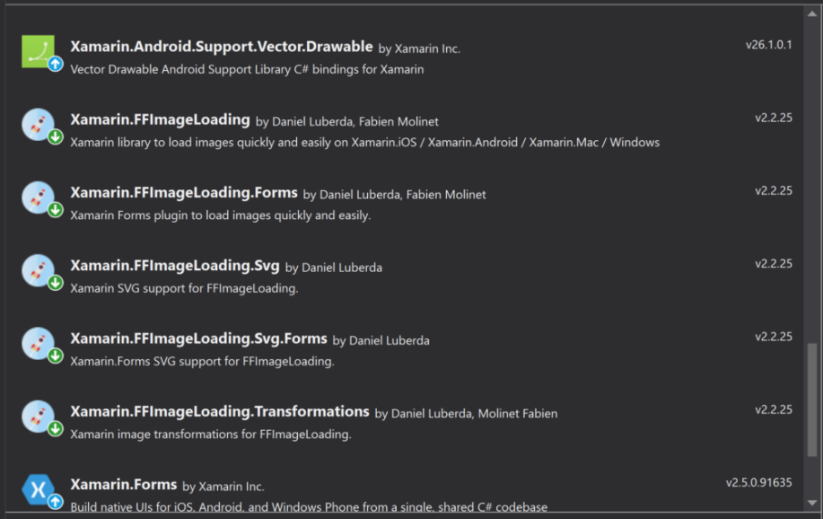

Llame a **CachedImageRenderer.Init ()** en cada plataforma. Vamos a ponerlo en **MainActivity.cs** de nuestro proyecto Android y **AppDelegate.cs** de iOS.

En archivo **MainActivity.cs** de Android. Para esta plataforma debemos declarar CachedImageRenderer.Init() con un valor de **TRUE**.

namespace Lands.Droid

{

using Android.App;

using Android.Content.PM;

using Android.OS;

using FFImageLoading.Forms.Droid;

[Activity(Label = "Lands", Icon = "@drawable/icon", Theme = "@style/MainTheme", MainLauncher = true, ConfigurationChanges = ConfigChanges.ScreenSize | ConfigChanges.Orientation)]

public class MainActivity : global::Xamarin.Forms.Platform.Android.FormsAppCompatActivity

{

protected override void OnCreate(Bundle bundle)

{

TabLayoutResource = Resource.Layout.Tabbar;

ToolbarResource = Resource.Layout.Toolbar;

base.OnCreate(bundle);

global::Xamarin.Forms.Forms.Init(this, bundle);

**CachedImageRenderer.Init(true);**

LoadApplication(new App());

}

}

}

En iOS en el archivo **AppDelegate.cs**

namespace Lands.iOS

{

using FFImageLoading.Forms.Touch;

using Foundation;

using UIKit;

// The UIApplicationDelegate for the application. This class is responsible for launching the

// User Interface of the application, as well as listening (and optionally responding) to

// application events from iOS.

[Register("AppDelegate")]

public partial class AppDelegate : global::Xamarin.Forms.Platform.iOS.FormsApplicationDelegate

{

//

// This method is invoked when the application has loaded and is ready to run. In this

// method you should instantiate the window, load the UI into it and then make the window

// visible.

//

// You have 17 seconds to return from this method, or iOS will terminate your application.

//

public override bool FinishedLaunching(UIApplication app, NSDictionary options)

{

global::Xamarin.Forms.Forms.Init();

**CachedImageRenderer.Init();**

LoadApplication(new App());

return base.FinishedLaunching(app, options);

}

}

}

Luego añadimos al xmlns las librerías de FFImageLoading en **LandPage.cs**.

<ContentPage xmlns="http://xamarin.com/schemas/2014/forms"

xmlns:x="http://schemas.microsoft.com/winfx/2009/xaml"

x:Class="Lands.Views.LandPage"

xmlns:ffimageloading="clr-namespace:FFImageLoading.Forms;assembly=FFImageLoading.Forms"

xmlns:fftransformations="clr-namespace:FFImageLoading.Transformations;assembly=FFImageLoading.Transformations"

xmlns:ffimageloadingsvg="clr-namespace:FFImageLoading.Svg.Forms;assembly=FFImageLoading.Svg.Forms"

BindingContext="{Binding Main,Source={StaticResource Locator}}"

Icon="ic_info">

Luego cargamos el diccionario de recursos.

<ContentPage.Resources>

<ResourceDictionary>

<ffimageloadingsvg:SvgImageSourceConverter x:Key="SvgImageSourceConverter">

</ffimageloadingsvg:SvgImageSourceConverter>

</ResourceDictionary>

</ContentPage.Resources>

Luego cargamos la imagen.

<ffimageloading:CachedImage WidthRequest="200" HeightRequest="200" Source="{Binding Land.Flag2, Converter={StaticResource SvgImageSourceConverter}}">

</ffimageloading:CachedImage>

Mi código de la View **LandPage.cs** quedo de la siguiente manera.

<?xml version="1.0" encoding="utf-8" ?>

<ContentPage xmlns="http://xamarin.com/schemas/2014/forms"

xmlns:x="http://schemas.microsoft.com/winfx/2009/xaml"

x:Class="Lands.Views.LandPage"

xmlns:ffimageloading="clr-namespace:FFImageLoading.Forms;assembly=FFImageLoading.Forms"

xmlns:fftransformations="clr-namespace:FFImageLoading.Transformations;assembly=FFImageLoading.Transformations"

xmlns:ffimageloadingsvg="clr-namespace:FFImageLoading.Svg.Forms;assembly=FFImageLoading.Svg.Forms"

BindingContext="{Binding Main,Source={StaticResource Locator}}"

Icon="ic_info">

<!--Title="Land" https://github.com/luberda-molinet/FFImageLoading/issues/456 -->

<ContentPage.Resources>

<ResourceDictionary>

<ffimageloadingsvg:SvgImageSourceConverter x:Key="SvgImageSourceConverter"></ffimageloadingsvg:SvgImageSourceConverter>

</ResourceDictionary>

</ContentPage.Resources>

<ContentPage.Content>

<ScrollView

BindingContext="{Binding Land}"

BackgroundColor="Silver">

<StackLayout

Padding="10">

<ffimageloading:CachedImage WidthRequest="200" HeightRequest="200"

Source="{Binding Land.Flag2, Converter={StaticResource SvgImageSourceConverter}}">

</ffimageloading:CachedImage>

<Label

FontAttributes="Bold"

FontSize="Large"

HorizontalOptions="Center"

Text="{Binding Land.Name}"

TextColor="Black">

</Label>

<Grid>

<Grid.ColumnDefinitions>

<ColumnDefinition Width="*"></ColumnDefinition>

<ColumnDefinition Width="*"></ColumnDefinition>

</Grid.ColumnDefinitions>

<Label

Grid.Column="0"

Grid.Row="0"

VerticalOptions="EndAndExpand"

FontAttributes="Bold"

FontSize="Medium"

Text="Capital:"

TextColor="Black">

</Label>

<Label

Grid.Column="1"

Grid.Row="0"

HorizontalOptions="CenterAndExpand"

FontAttributes="Bold"

VerticalOptions="EndAndExpand"

Text="{Binding Land.Capital}"

TextColor="Black">

</Label>

<Label

Grid.Column="0"

Grid.Row="1"

VerticalOptions="EndAndExpand"

FontAttributes="Bold"

FontSize="Medium"

Text="Population:"

TextColor="Black">

</Label>

<Label

Grid.Column="1"

Grid.Row="1"

HorizontalOptions="CenterAndExpand"

FontAttributes="Bold"

VerticalOptions="EndAndExpand"

Text="{Binding Land.Population, StringFormat='{0:N0}'}"

TextColor="Black">

</Label>

<Label

Grid.Column="0"

Grid.Row="2"

VerticalOptions="EndAndExpand"

FontAttributes="Bold"

FontSize="Medium"

Text="Area:"

TextColor="Black">

</Label>

<Label

Grid.Column="1"

Grid.Row="2"

FontAttributes="Bold"

HorizontalOptions="CenterAndExpand"

VerticalOptions="EndAndExpand"

Text="{Binding Land.Area, StringFormat='{0:N0}'}"

TextColor="Black">

</Label>

<Label

Grid.Column="0"

Grid.Row="3"

VerticalOptions="EndAndExpand"

FontAttributes="Bold"

FontSize="Medium"

Text="Alpha Code 2:"

TextColor="Black">

</Label>

<Label

Grid.Column="1"

Grid.Row="3"

HorizontalOptions="CenterAndExpand"

FontAttributes="Bold"

VerticalOptions="EndAndExpand"

Text="{Binding Land.Alpha2Code}"

TextColor="Black">

</Label>

<Label

Grid.Column="0"

Grid.Row="4"

VerticalOptions="EndAndExpand"

FontAttributes="Bold"

FontSize="Medium"

Text="Alpha Code 3:"

TextColor="Black">

</Label>

<Label

Grid.Column="1"

Grid.Row="4"

HorizontalOptions="CenterAndExpand"

FontAttributes="Bold"

VerticalOptions="EndAndExpand"

Text="{Binding Land.Alpha3Code}"

TextColor="Black">

</Label>

<Label

Grid.Column="0"

Grid.Row="5"

VerticalOptions="EndAndExpand"

FontAttributes="Bold"

FontSize="Medium"

Text="Region:"

TextColor="Black">

</Label>

<Label

Grid.Column="1"

Grid.Row="5"

HorizontalOptions="CenterAndExpand"

FontAttributes="Bold"

VerticalOptions="EndAndExpand"

Text="{Binding Land.Region}"

TextColor="Black">

</Label>

<Label

Grid.Column="0"

Grid.Row="6"

FontAttributes="Bold"

FontSize="Medium"

Text="Subregion:"

TextColor="Black"

VerticalOptions="EndAndExpand">

</Label>

<Label

Grid.Column="1"

Grid.Row="6"

HorizontalOptions="CenterAndExpand"

FontAttributes="Bold"

VerticalOptions="EndAndExpand"

Text="{Binding Land.Subregion}"

TextColor="Black">

</Label>

<Label

Grid.Column="0"

Grid.Row="7"

FontAttributes="Bold"

FontSize="Medium"

Text="Demonym:"

TextColor="Black"

VerticalOptions="EndAndExpand">

</Label>

<Label

Grid.Column="1"

Grid.Row="7"

HorizontalOptions="CenterAndExpand"

FontAttributes="Bold"

VerticalOptions="EndAndExpand"

Text="{Binding Land.Demonym}"

TextColor="Black">

</Label>

<Label

Grid.Column="0"

Grid.Row="8"

FontAttributes="Bold"

FontSize="Medium"

Text="GINI:"

TextColor="Black"

VerticalOptions="EndAndExpand">

</Label>

<Label

Grid.Column="1"

Grid.Row="8"

HorizontalOptions="CenterAndExpand"

FontAttributes="Bold"

VerticalOptions="EndAndExpand"

Text="{Binding Land.Gini, StringFormat='{0:N2}'}"

TextColor="Black">

</Label>

<Label

Grid.Column="0"

Grid.Row="9"

FontAttributes="Bold"

FontSize="Medium"

Text="GINI:"

TextColor="Black"

VerticalOptions="EndAndExpand">

</Label>

<Label

Grid.Column="1"

Grid.Row="9"

HorizontalOptions="CenterAndExpand"

FontAttributes="Bold"

VerticalOptions="EndAndExpand"

Text="{Binding Land.Gini, StringFormat='{0:N2}'}"

TextColor="Black">

</Label>

<Label

Grid.Column="0"

Grid.Row="10"

FontAttributes="Bold"

FontSize="Medium"

Text="Native Name:"

TextColor="Black"

VerticalOptions="EndAndExpand">

</Label>

<Label

Grid.Column="1"

Grid.Row="10"

HorizontalOptions="CenterAndExpand"

FontAttributes="Bold"

VerticalOptions="EndAndExpand"

Text="{Binding Land.NativeName}"

TextColor="Black">

</Label>

<Label

Grid.Column="0"

Grid.Row="11"

FontAttributes="Bold"

FontSize="Medium"

Text="Numeric Code:"

TextColor="Black"

VerticalOptions="EndAndExpand">

</Label>

<Label

Grid.Column="1"

Grid.Row="11"

HorizontalOptions="CenterAndExpand"

FontAttributes="Bold"

VerticalOptions="EndAndExpand"

Text="{Binding Land.NumericCode}"

TextColor="Black">

</Label>

<Label

Grid.Column="0"

Grid.Row="12"

FontAttributes="Bold"

FontSize="Medium"

Text="CIOC:"

TextColor="Black"

VerticalOptions="EndAndExpand">

</Label>

<Label

Grid.Column="1"

Grid.Row="12"

HorizontalOptions="CenterAndExpand"

FontAttributes="Bold"

VerticalOptions="EndAndExpand"

Text="{Binding Land.Cioc}"

TextColor="Black">

</Label>

</Grid>

</StackLayout>

</ScrollView>

</ContentPage.Content>

</ContentPage>